

User Manual
June 12, 2015

ISEP EPS Team 4

Arick Davis - Francisco José Ruiz Ludeña - Jan Rozewski - Katoo Van Tendeloo
- Rasmus von Bröckel - Stroe Viorel Dragos
Table of contents
1) Introduction 1
2) What does Aquaponic admin do? 1
3) How do I use the website? 2
4) How can I modify the hardware? 6
5) Further concers 8

Introduction
Aquaponic Admin is an all-in-one solution to monitoring your aquaponics system. The Aquaponic Admin system is an integrated hardware and software suite that reduces the effort needed for monitoring while increasing efficiency and sustainability of your aquaponics system.

What does Aquaponic admin do?
Aquaponic Admin includes sensors for temperature, water pump flow, water depth, and a feeder status. In addition there are smart outlets designed to control your existing heater and water pump. All of these sensors and controls can be managed and updated via the website: ave.dee.isep.ipp.pt/~Aquaponics/ . This web address will take you to the home page shown below.
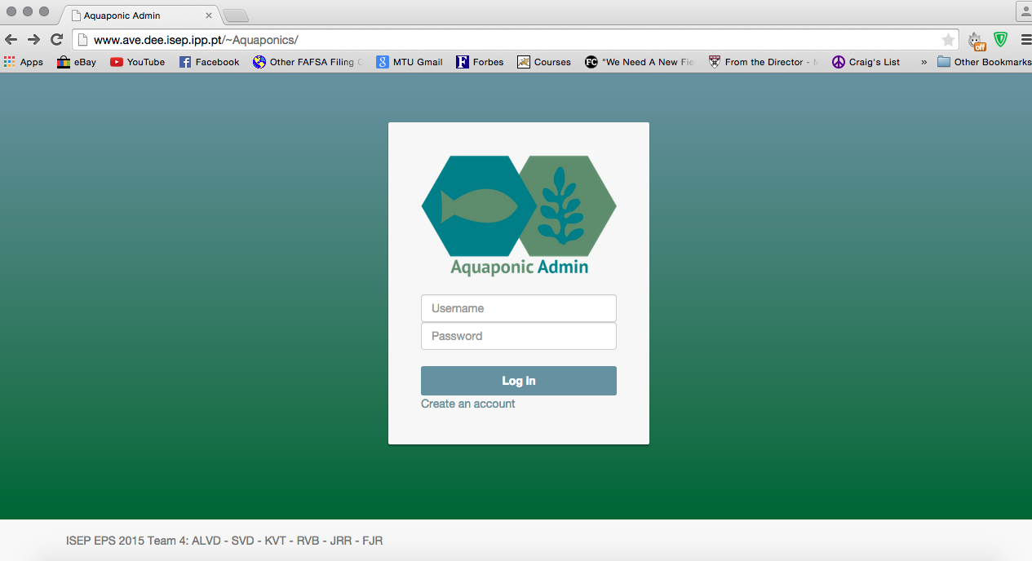

How do I use the website?
The Aquaponic Admin website is extremely simple to navigate. To register for an account go to the Aquaponic Admin home page: ave.dee.isep.ipp.pt/~Aquaponics/ and click the ‘Create an account’ link pointed to below.
Now enter all of the listed fields. The email address you supply will be used to notify you with important information regarding your aquaponics system. You will need a verify code to register. This is available from the website Administrator. The default verify code is 1.
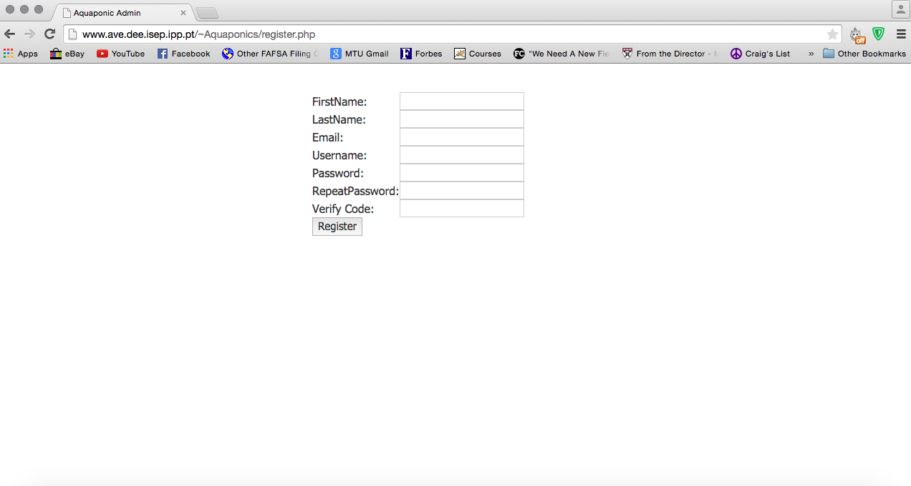
Once all the fields are complete click the register button. If all of the fields were filled correctly you will see the message pointed to below. Click the link to return to the home page and enter your chosen username and password.
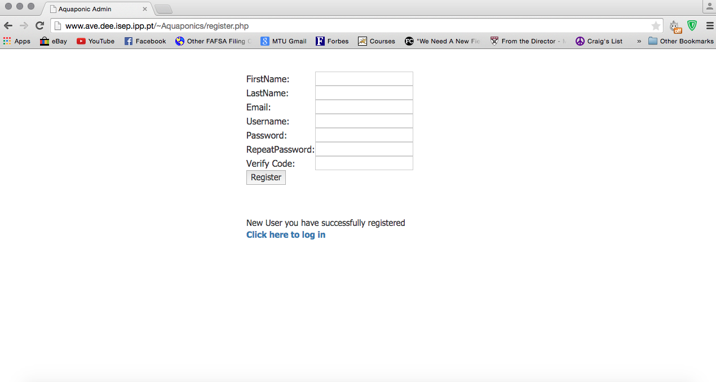
Once logged in you will be redirected to the Check Status page. This page shows the most recent readings form the tank sensors. Form here you can use the navigation bar at the top of the page to access the other pages.
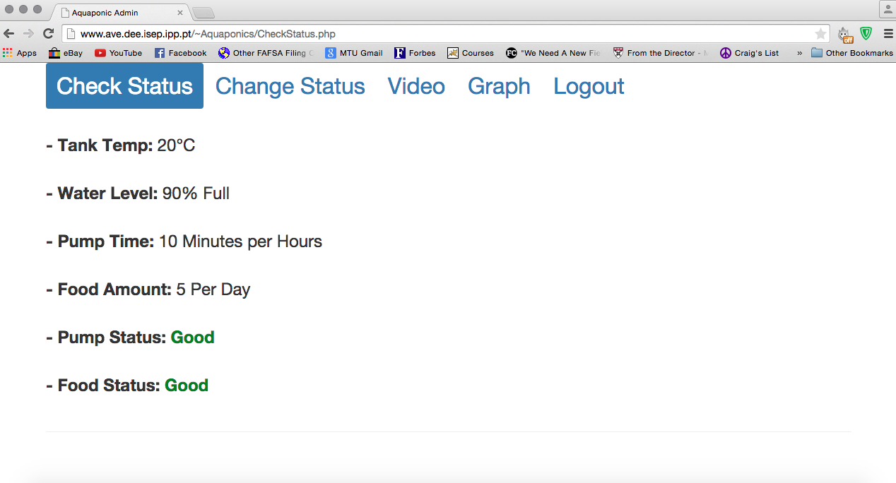
The Change Status page allows you to change the desired water temperature, how many minutes the pump is on per hour, how much food is dispensed from the feeder per day, and switch the tank light on or off. The initial values on this page are the current settings. Pressing a ‘ – ‘ symbol will decrease the setting by one. Pressing a ‘ + ’ symbol will increase the setting by one. Once you have reached your desired settings press the ‘ Send ‘ button to save the changes. 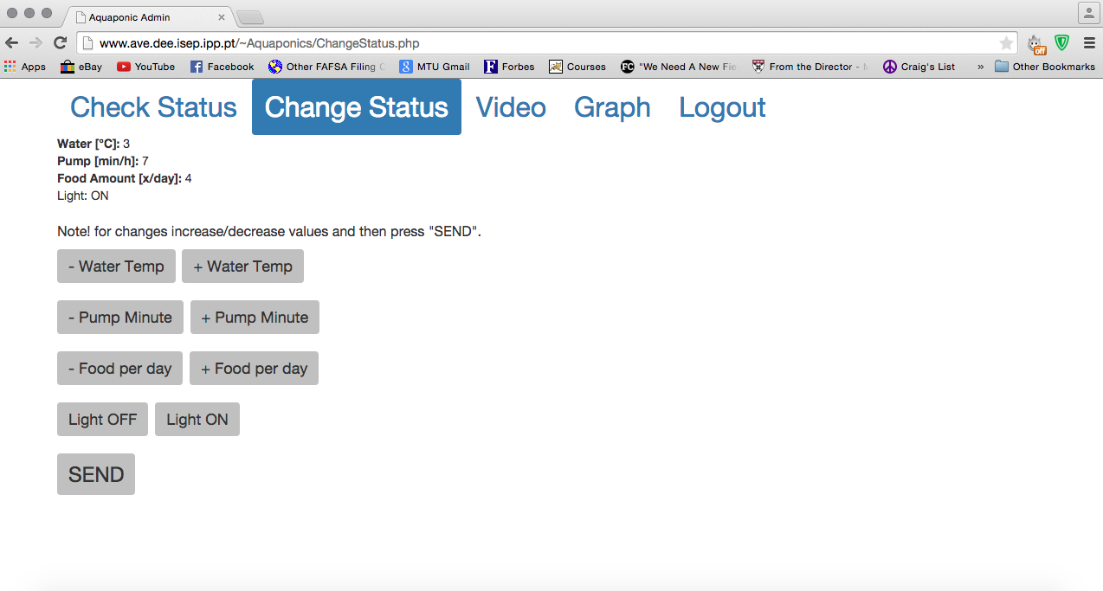
At this time the Video and Graph features are in development. Once you are done monitoring you aquaponics system press the Logout tab.
In addition to these basic features there is an administrative account. Logging in with the administrative credentials will allow you to change the verification code. Simply login to the administrative account and click ‘change verify code’. Then enter your new verify code.
Administrative Credentials
Username: admin2015
Password: isepadmin
Default Verification Code: 1
For more information on the setup and functions of the website and adjoining database please refer the full Aquapoinc Admin report: http://www.eps2015-wiki4.dee.isep.ipp.pt/doku.php?id=report#project_development

How can I modify the HARDWARE?
Aquaponic Admin was originally designed to be a closed system. We understand that at some point you may want to make changes to the hardware or software. Below are images of the physical unit.
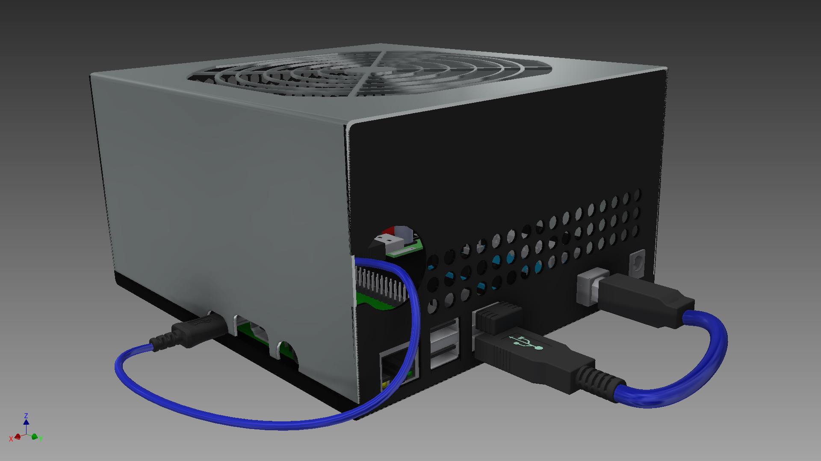
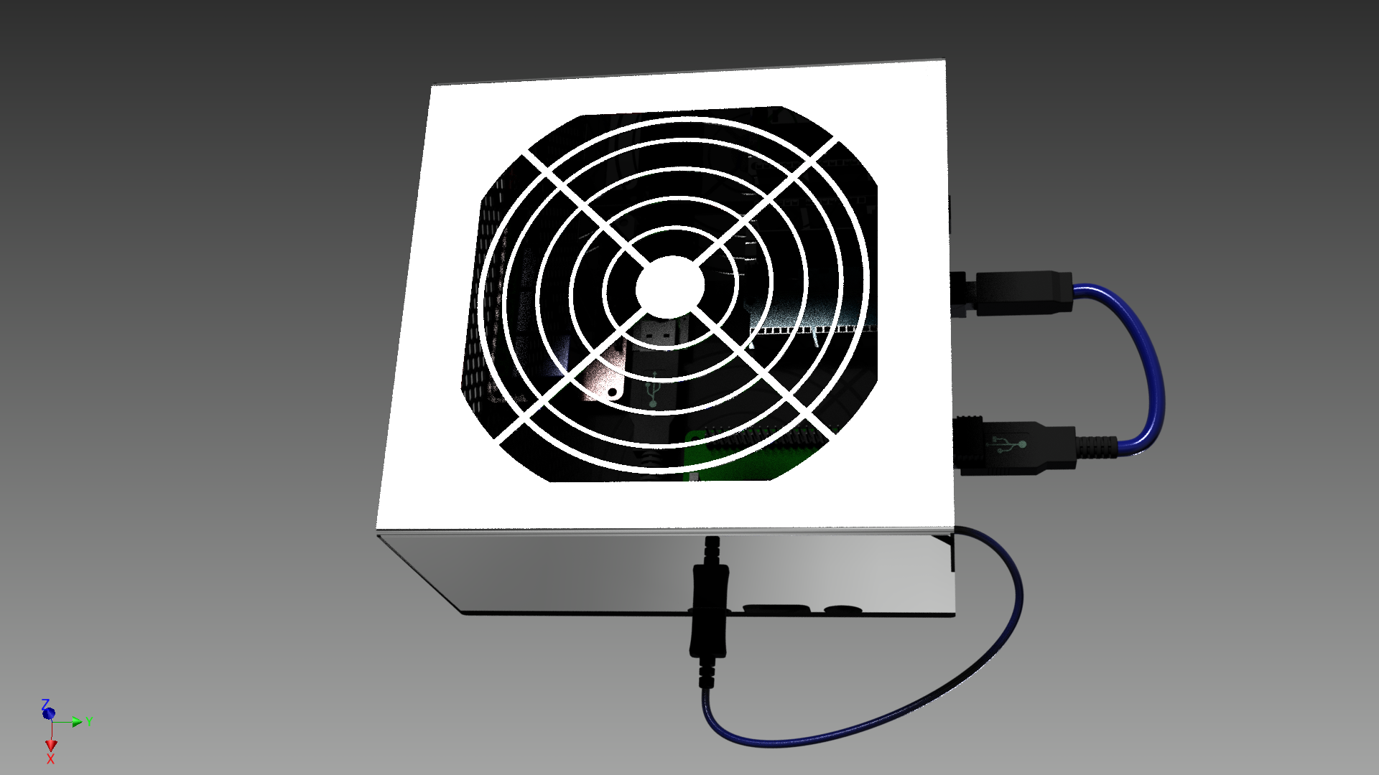
Remove all exterior screws and lift the cover to access the internal components.
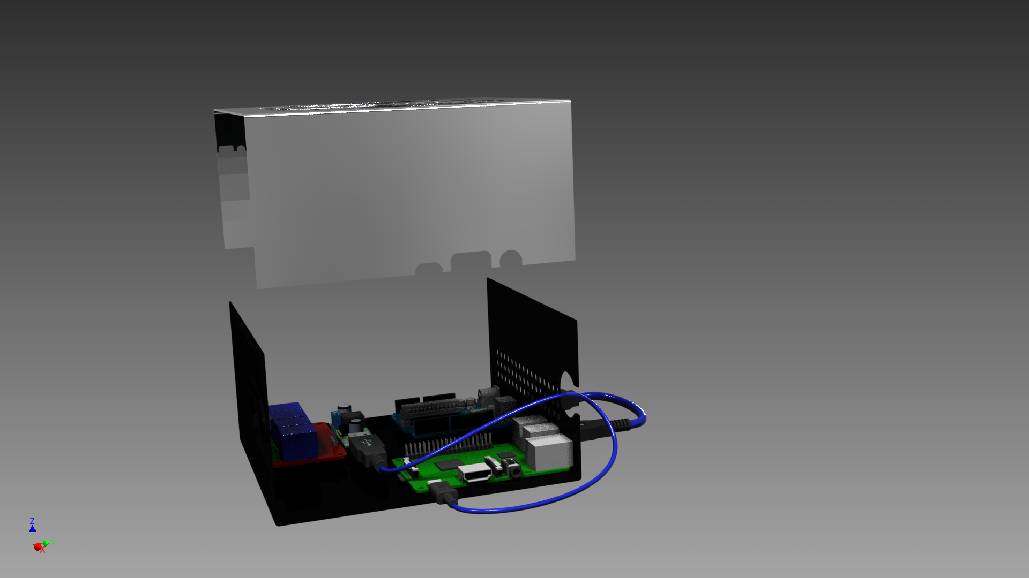
- 12V power supply
- Arduino Uno
- 12V to 5v converter
- 4 channel relay
- Raspberry Pi B+
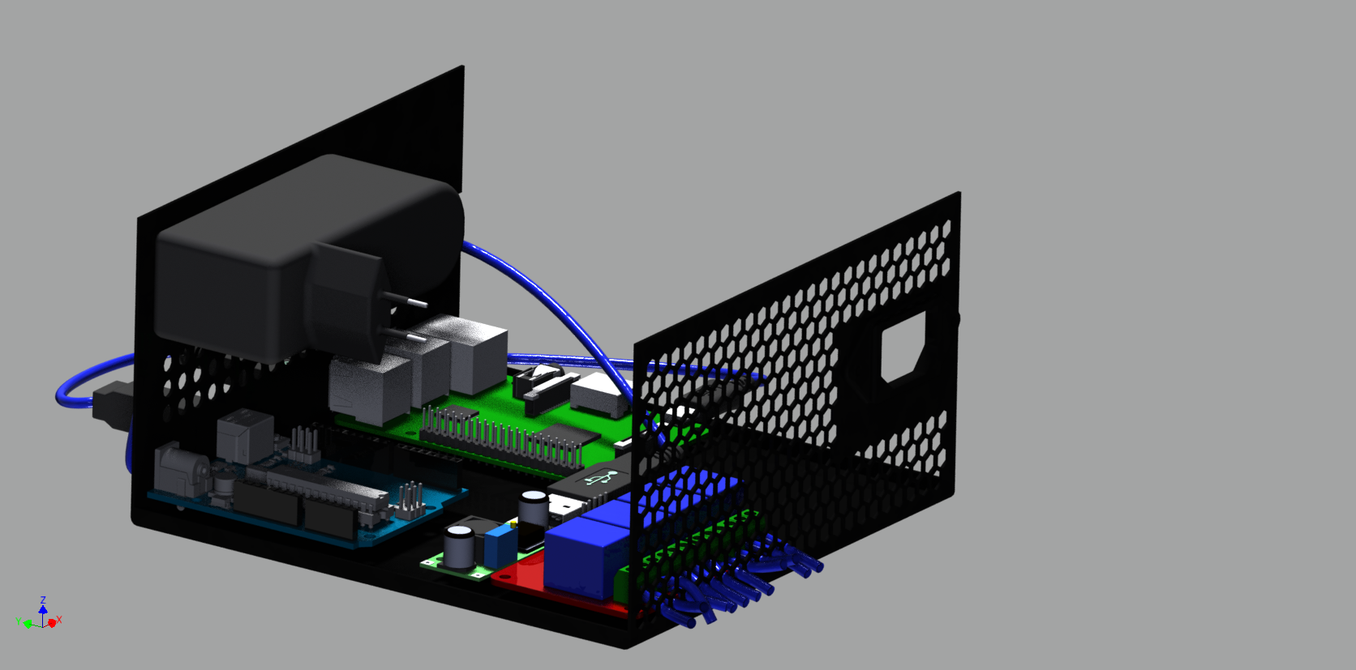

5
4
3
2
1

For more information on the hardware setup please refer the full Aquapoinc Admin report: http://www.eps2015-wiki4.dee.isep.ipp.pt/doku.php?id=report#project_development

Further concers

