

User Manual
June 12, 2015

ISEP EPS Team 4

Arick Davis - Francisco José Ruiz Ludeña - Jan Rozewski - Katoo Van Tendeloo
- Rasmus von Bröckel - Stroe Viorel Dragos
Table of contents
1) Introduction 3
2) What does Aquaponic admin do? 3
3) Register Webpage 5
4) How do I use the website? 7

Introduction
Do you have aquaponic system at home? Do you want to control your system from anywhere in the world? Aquaponic Admin is an all-in-one solution to monitoring your aquaponics system. The Aquaponic Admin system is an integrated hardware and software suite that reduces the effort needed for monitoring while increasing efficiency and sustainability of your aquaponics system. Admin Acuaponic consists of: a heater, water pump, Webcam, LED light, sensor to control the temperature, water pump flow and water depth sensor.

What does Aquaponic admin do?
Aquaponics Admin intends to control your system from anywhere. From the website ave.dee.isep.ipp.pt/~Aquaponics/ you can control:
- The temperature of the fishes: with Aquaponic Admin, you can determine the temperature of your fishes. If the temperature is lower than the established temperature in the system, the boiler will start working. We get keep the fishes at the same temperature.
- Water level: The water level sensor informs us of the water capacity of the tank. You know when you need to refill the water tank.
- Water flow: determines the flow rate of the water pump that pushes water from the tank to the plants. The system recognizes when the system is not working properly.
- Feeder: with Aquaponic Admin, you can control the amount of food it throw the feeder to the fishes per day. This system also determines the level of food in the trough. In this way the user knows when he has to refill the feeder.
- Camera: let to know the fishes conditions. Through the camera, we can see if there is any anomaly in the behavior of the fishes and solve it.
- LED lighting: to see the fishes better, we have an LED light. This light can be turned on or off when we consider appropriate from the Acuaponic Admin.
So all of these functions can be controlled from anywhere if our mobiles devices have an internet connection.

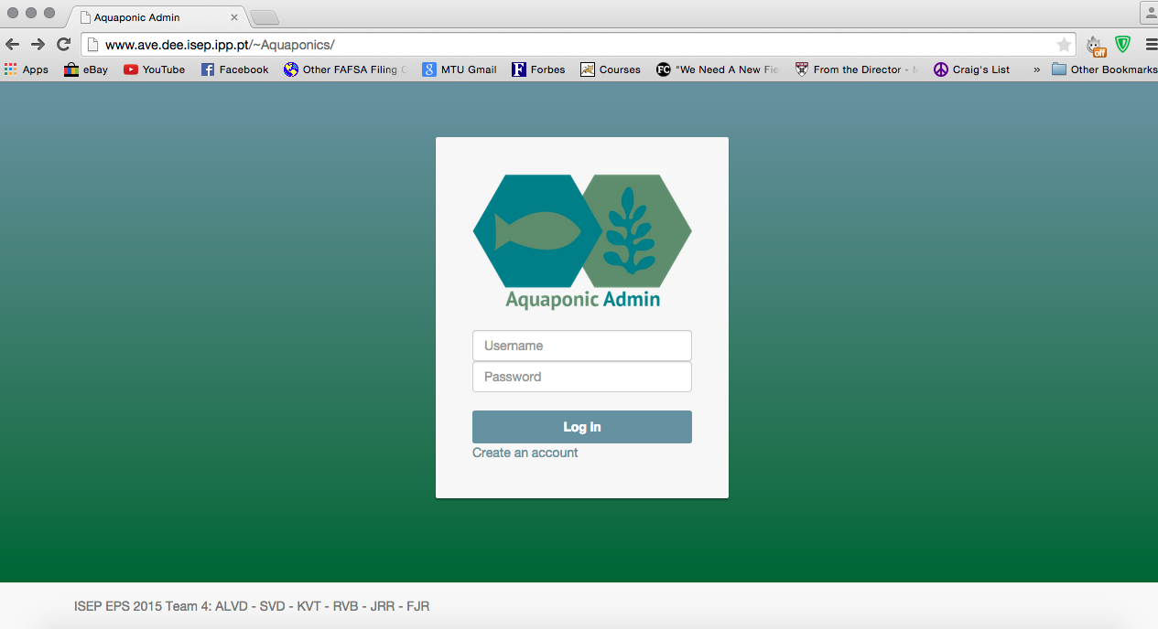

REGISTER WEBPAGE
The Aquaponic Admin website is extremely simple to navigate. To register for an account go to the Aquaponic Admin home page: ave.dee.isep.ipp.pt/~Aquaponics/ and click the ‘Create an account’ link pointed to below.

Now enter all of the listed fields. The email address you supply will be used to notify you with important information regarding your aquaponics system. You will need a verify code to register. This is available from the website Administrator. The default verify code is 1.
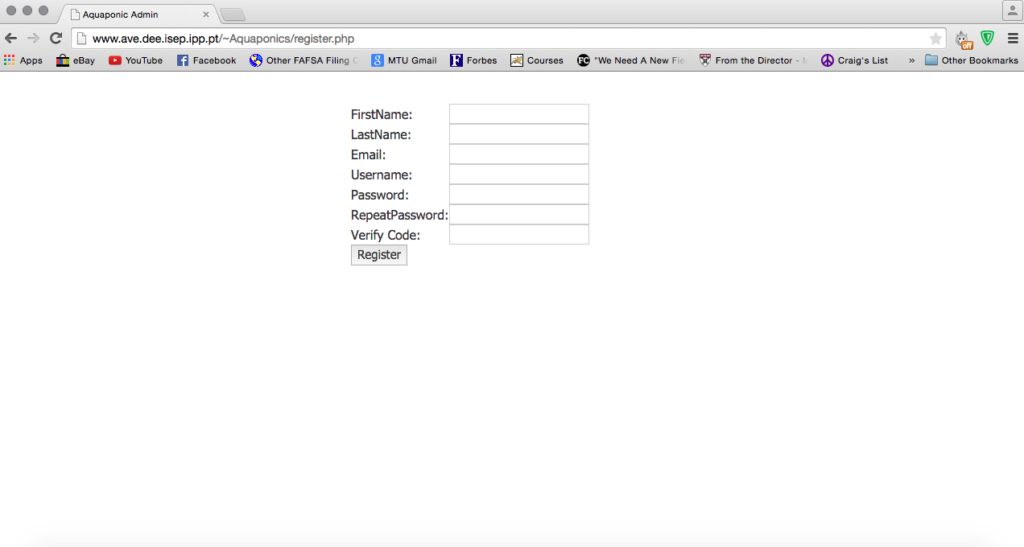
Once all the fields are complete click the register button. If all of the fields were filled correctly you will see the message pointed to below. Click the link to return to the home page and enter your chosen username and password.

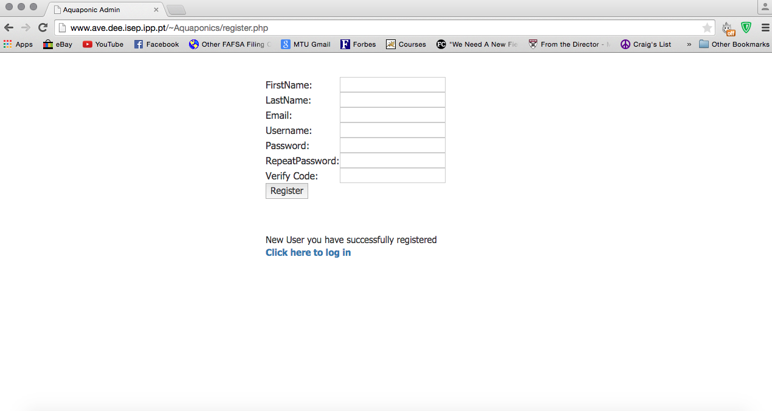

How do I use the website?
Once we have already registered on the website, we can begin to change the parameters. Looking at the main Aquaponic Admin we see at the top of the page, different sections: Check Status, Change Status, Video, Graph and Logout. We will analyze each of them.
- Check Status: This section allows you to view the status of our aquaponic system e.g. water level or temperature. We will analyze the various data provided in this section:
  - Tank Temp: report the temperature at which the tank is located. The temperature is chosen by the user and can be modified as explained later. If the tank temperature is lower than that set by the customer, the boiler starts working.
  - Water level: Indicates the water level in the tank. If the level is low the user will have to fill the tank.
  - Pump Time: Indicates the number of minutes that the pump works, taking water for watering plants.
  - Food amount: Sets how many times a day the feeder throws food the fishes.
  - Pump Status: Indicates whether the pump is working properly or if there is an abnormality in it.
  - Food Status: Indicates whether the feeder has food. If the feeder is empty Aquaponic Admin informs us.

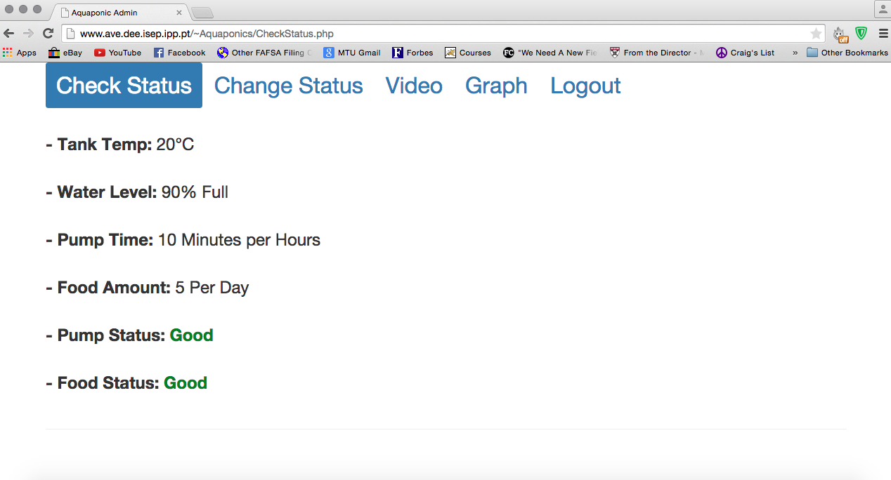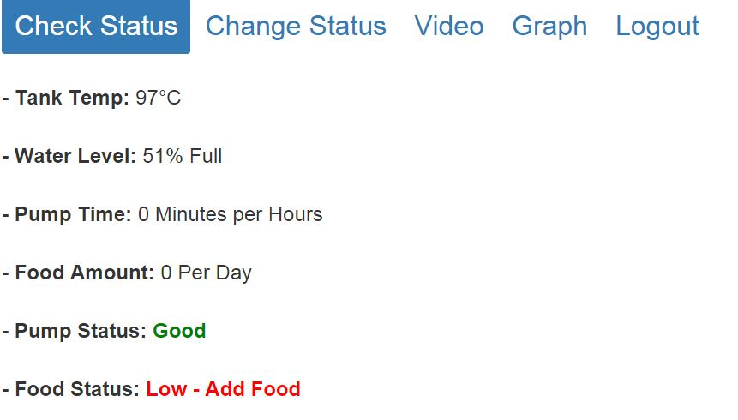

- Change Status: The Status Change page allows you to change the desired water temperature, the number of minutes that the pump works in an hour, the amount of food that is dispensed from the feeder by day, and switch on the light tank or turned off. At the top of the page indicates the parameters established in the Aquaponic Admin. ( Water [⁰C], Pump [min/h], Food Amount [x/h] and light).

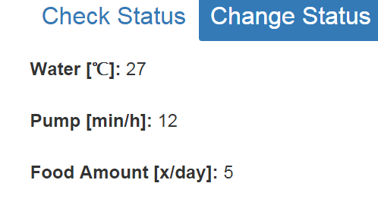

  - Water: To modify the tank temperature, press "- Water Temp" for reduce the temperature. To increase the temperature, press "+ Water Temp".
  - Pump: if you want to change how many minutes per hour the pump is on, press “- pump minute” for reduce, and “+ pump minute” for increase.

  - Food Amount: You can change the amount of food that is dispensed from the feeder per day. Pressing "- Food per day" reduces the amount of food, pressing "+ Food per day" increases the amount of food.
  - Light: Pressing "light off" the light aquaponic system is switched off , instead pressing "light ON" light is switched on
In all parameters, pressing a symbol “-“ decrease the setting by one. Pressing a “+” symbol increase the setting by one. Once you have reached your desired settings press the “Send” button to save the changes.

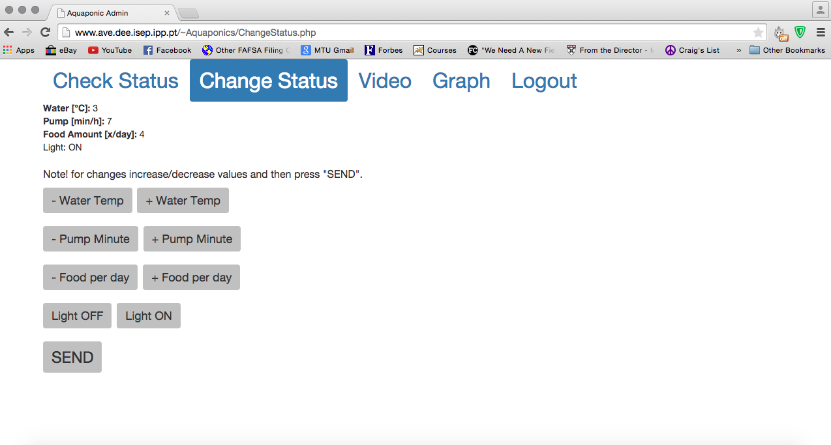

- Video and Graph: are in development.

- Logout : Once you are done monitoring you aquaponics system press the Logout tab.

In addition to these basic features there is an administrative account. Logging in with the administrative credentials will allow you to change the verification code. Simply login to the administrative account and click “change verifies code”. Then enter your new verify code.
Administrative Credentials
Username: admin2015
Password: isepadmin
Default Verification Code: 1
For more information on the setup and functions of the website and adjoining database please refer the full Aquapoinc Admin report: http://www.eps2015-wiki4.dee.isep.ipp.pt/doku.php?id=report#project_development

